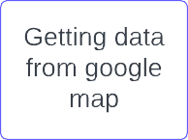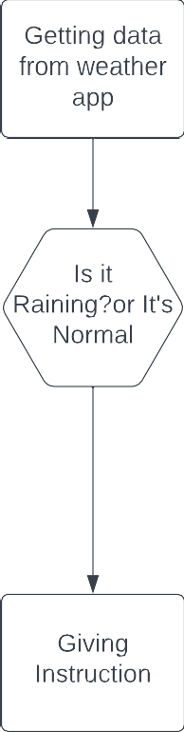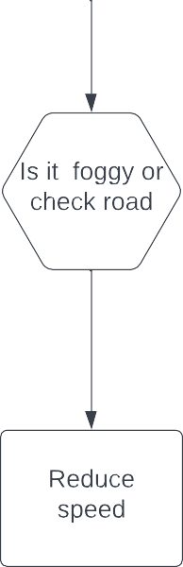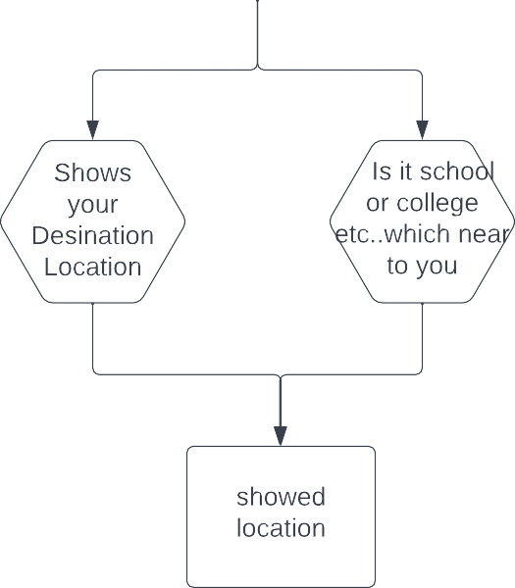

Project Design Phase-II

|  |  |
| --- | --- |
| Date | 04 November 2022 |
| Team ID | PNT2022TMID22104 |
| Project Name | Sign with smart connectivity for better Road safety |
| Maximum Marks | 4 Marks |